**Tenses**

Tenses are those rules that tells us **at what time** and **how much** any Verb/Work has done.  
Ex: I’m teaching you.

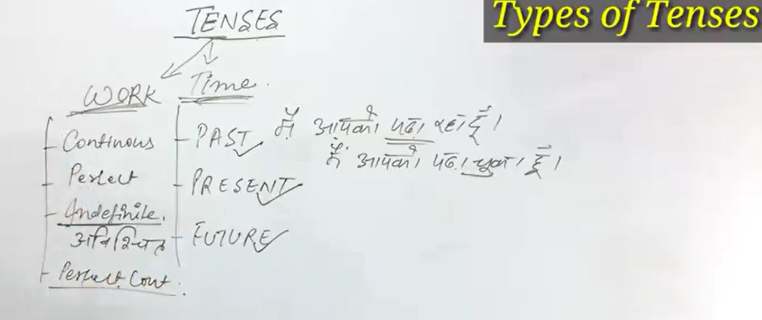

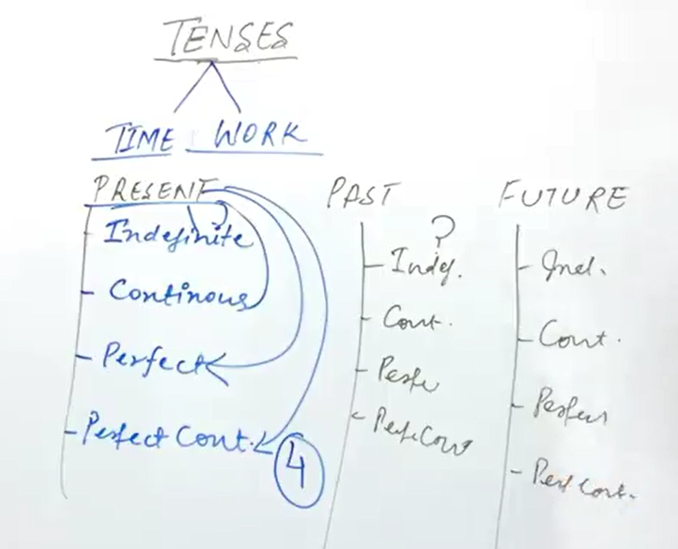

**Helping Verb:-**

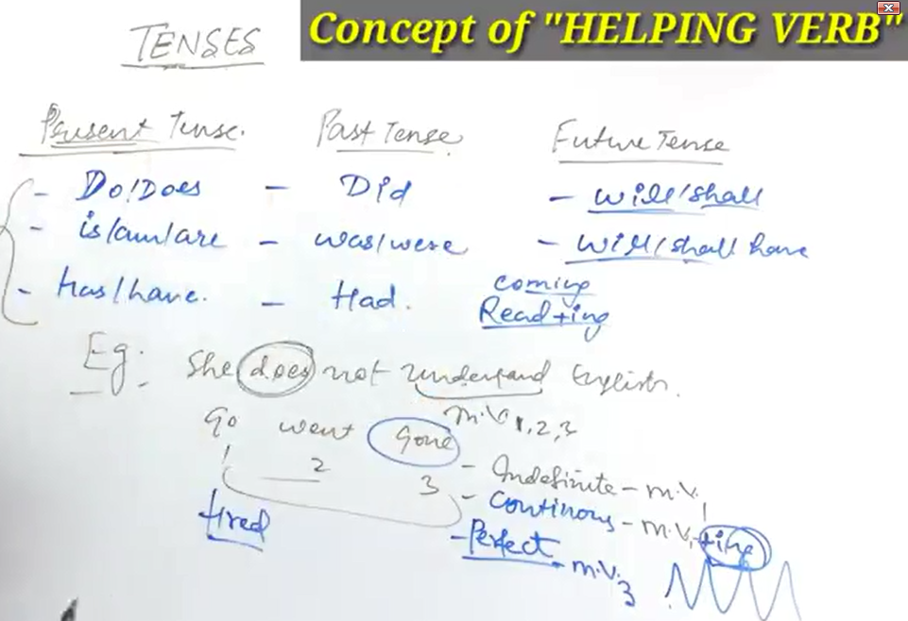

**Note:-**

* Indefinite means (Aanishchit) those work/verb that doesn’t indicate the work has done or not  
  Ex: Those work indicate Schedule, Routine, Habbits etc.
* Continuous means work is going on.
* Perfect means work has perfectly done
* Do/Does are helping Verb

**Type of Sentences:-**

1. Affermative (Normal or Positive)
2. Negative
3. Interrogative (Question Ask): Interrogative Sentence whose answer should be given in Yes or No.  
   “?” Mark of Interrogation
4. Double Interrogative: Interrogative Sentence whose answer should be given in detail.  
   WH Family Use: What, when, why where, which, whom

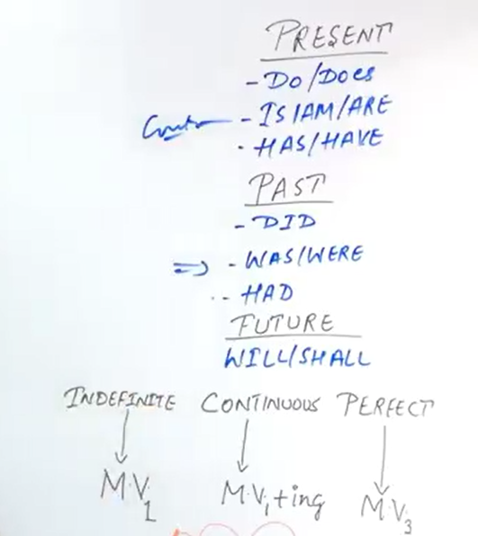

**Examples (Present Tense):-**

**Present Indefinite Tense:**

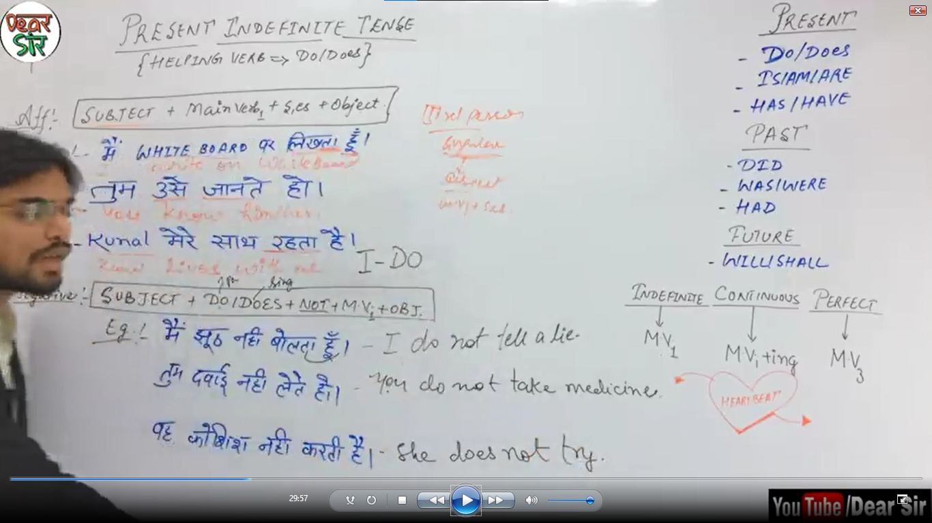

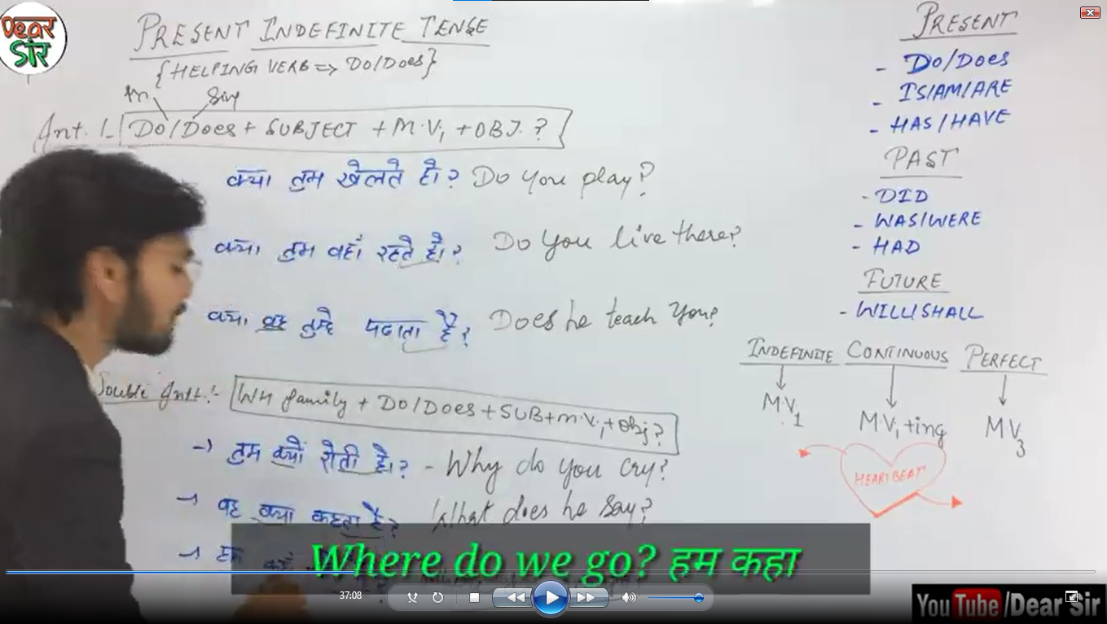

**My Example:-**1. Main Jhoot nhi bolta hoon. (Affermative)  
Ans: I do not tell a lie.  
2. Tum kyon Rooti ho? (Double Interrogative)  
Ans: Why do you cry  
  
3. Hum kahaan Jatan Haa?  
Ans: Where do we go?

**Present Continuous Tense:**

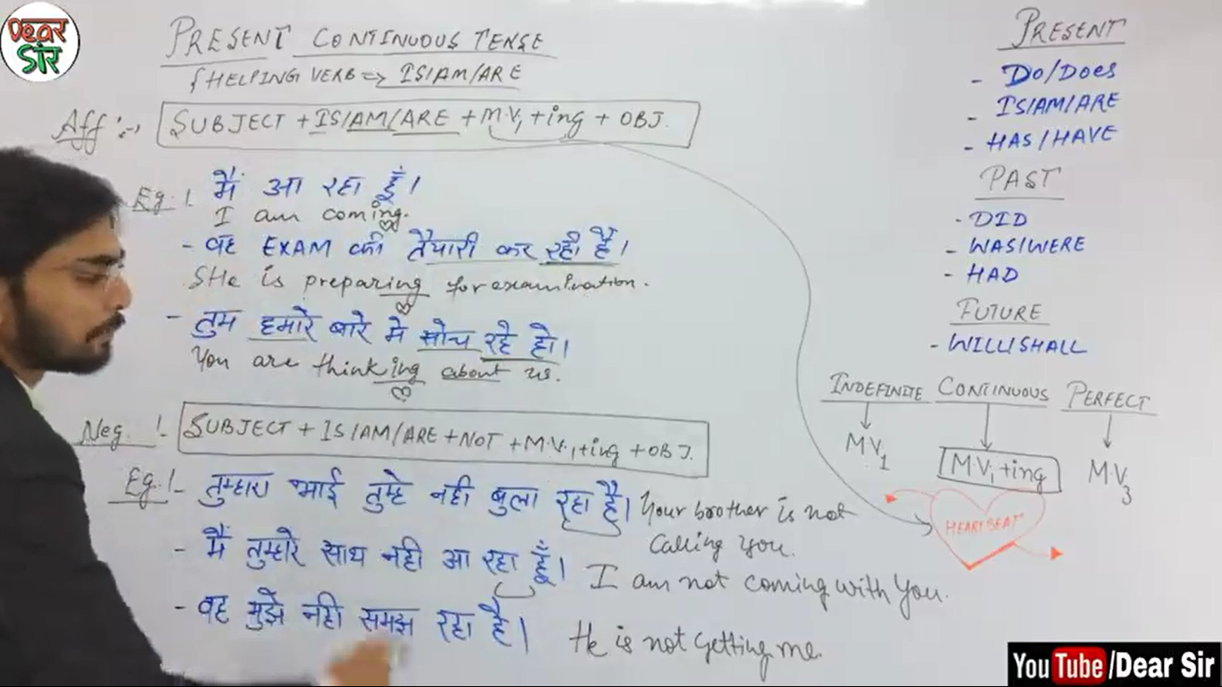

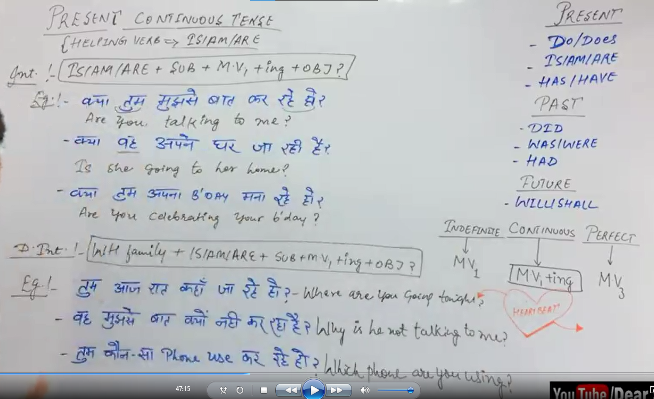

**My Examples:**

1. Waah Exam ki Tayaari kar rhi ha.  
   Ans: She is preparing for examination.
2. Waah mujhe nhi smaj rha ha.  
   Ans: He is not getting me.
3. Kya waah apna Ghar ja rhi ha?  
   Ans: Is she going to her home?
4. Waah mujhse Baat kyon nhi kar rha ha?  
   Ans: Why is he not talking to me?

**Present Perfect Tense:**

**Note:**

Helping Verb: Has/Have  
Has: Singular (He/she/It)  
Have: Plural (You/We/They), I (Exception)

**Structure:**In Eng: (Affermative)  
Subject + Helping Verb(has/have) + Main Verb V3 + Object

In Eng: (Interrogative)  
Helping Verb(has/have) + Subject + Main Verb V3 + Object  
  
In Eng: (Double Interrogative)  
WH Family + Helping Verb(has/have) + Subject + Main Verb V3 + Object

**My Examples:**

1. Main(Sub) Khanna(Obj) kha(Main Verb V3) chukka hoon (Helping Verb)  
   Ans: I(Sub) have(Helping Verb) eaten(Main Verb V3) the food (Obj).
2. Hum Ussa Mil Chukka Hain. (Affermative)  
   Ans: We have met him/her(Depends on the Gender).
3. Waah tumse mill chukka ha  
   Ans: He has met you
4. Maina Taj Mahal nhi dekha ha (Negative)  
   Ans: I have not seen the Taj Mahal.
5. Waah Ghar nhi Pahuncha Ha  
   Ans: He has not reached the home.
6. Kya tum Match Geet Chuka Ho? (Interrogative)  
   Ans: Have you won the Match?
7. Kya tumna kaam kar liya ha?  
   Ans: Have you done the work?
8. Tumna kaam kaisa kar liya ha? (Double Interrogative)  
   Ans: How have you done the work?
9. Kab tumna match Geeta?  
   Ans: When have you won the match?

**Present Perfect Continuous Tense:**

**Note:**

* Issh Tense main pta hota haan ki kaam kaab se chaal rha ha.
* Helping Verb: Has been/Have been  
  Has: Singular (He/she/It)  
  Have: Plural (You/We/They), I (Exception)  
  Here, Been is included in helping verb for sake of convenience but helping verb is has/have only.
* Ex:  
  Main apko pdha rha hoon. (Present Continuous Tense)  
  Ans: I’m teaching you  
    
  Main apko 10 saal sa pdha rha hoon (Present Perfect)  
  Ans: I have been teaching you for 10 years.
* Since – Exact/Fix/Definite Timing ka saath lagta ha  
  For – Indefinite Timing ka liya use hota ha

**Structure:**In Eng: (Affermative)  
Subject + Helping Verb(has been/have been) + Main Verb V4 (ing) + Object + Since/For + time

In Eng: (Negative)  
Subject + Helping Verb(has not been/have not been) + Main Verb V4 (ing) + Object + Since/For + time

In Eng: (Interrogative)  
Helping Verb(has /have) + Subject + been + Main Verb V4 (ing) + Object + Since/For + time

In Eng: (Double Interrogative)  
WH Family + Helping Verb(has /have) + Subject + been + Main Verb V4 (ing) + Object + Since/For + time

**My Examples:**

1. Main(I Sub) aapka(for you Obj) subah sa(since moring) intazaar kar rha(waiting V4) hoon(have been hlping Verb) --(Affermative)  
   Ans: I have been waiting for you since morning.
2. Waah 2 diin sa kosis kar rha ha.  
   Ans: He has been trying for 2 days.
3. Tum 1980 sa Delhi ma Rah rha hoo?Ans: You have been living/residing in Delhi since 1980?
4. Apka Beta 2 din san hi aarha ha – (Negative)  
   Ans: Your son has not been coming to school for 2 days.
5. Priyanka saam sa apna lesson yaad kar rhi ha.  
   Ans: Priyanka has been learning her lesson since evening.
6. Kya tum 10 saal sa yhaan kaam kar rha ho? (Interrogative)  
   Ans: Have you been working here for 10 years?

**Examples (Past Tense):-**

**Past Indefinite Tense:**

**Note:**

* V2 Verb only use in Past Tense of Indefinite in whole English Grammar
* Exception: Only in Past Indefinite Verb will be V2, rest(Present & Future) would be V1
* In present Perfect, hindi indicator will be: haa, hoon, ho etc. If it will not be there means it’s past Indefinite  
  Ex:  
  Waah AAgya ***haa***. (Present Perfect)  
  Ans: He has come.  
    
  Waah aa***ya***. (Past Indefinite)  
  Ans: He came
* Identifier in Hindi:  
  AA, EE, AAY, aW, Ta Tha, Ti Tthi, ta Tha
* Similarity between Present Indefinite & Past Indefinite is that both does not use Helping Verb.

**Structure:**

In Eng (Affermative):  
Subject + Main Verb (V2) + Object

In Eng (Negative):  
Subject + Did (2nd form of Do) + not + Main Verb (V1) + Object  
  
Once in a sentence, if we used 2nd form of helping verb (Did) then we don’t need of using 2nd form of Main Verb. That’s why above structure we’re using 1st form of Main verb.

In Eng (Interogative):  
Did (2nd form of Do) + Subject + Main Verb (V1) + Object  
  
In Eng (Double Interogative):  
WH Family + Did (2nd form of Do) + Subject + Main Verb (V1) + Object

**My Examples:**

1. Main Gyaa – (Affermative)  
   Ans: I went
2. Maina Ussa Pucha  
   Ans: I asked Him
3. Main Ghar wapas aay  
   Ans: I returned Home
4. Main isse janta tha jab main school main tha  
   Ans: I knew him when I was at school.
5. Hum ussa milaan  
   Ans: We met him
6. Mujhe mera papa na bolaya  
   Ans: My Father called me
7. Maina Jhoot nhi bola – (Negative)  
   Ans: I did not tell a lie.
8. Usna film nhi dekhi  
   Ans: He did not watch the film.
9. Mr. Deepak nah ma nhi pdaya  
   Ans: Mr. Deepak did not teach us.
10. Kya Tumne YouTube par video dekhi? – (Interrogative)  
    Ans: Did you watch the video on Youtube?
11. Kya usna pdai ki?  
    Ans: Did he Study?
12. Kya tumna likha?  
    Ans: Did you write?
13. Kya tumna class ma likha?  
    Ans: Did you write in the class?
14. Tumna mujha kyun bolaya? -- (Double Interrogative)  
    Ans: Why did you call me?
15. Tumna ussa kya khaa?  
    Ans: What did you say to him.
16. Tum whaan kyon gyn?  
    Ans: Why did you go there?

**Past Continuous Tense:**

**Note:**Past Continuous is similar to Present Continuous only the difference is in Helping Verb (was/were)

**Structure:**

In Eng (Affermative):  
Sub + Was/Were + Main Verb (V4 Ing) + Object

In Eng (Negative):  
Sub + Was/Were + not+ Main Verb (V4 Ing) + Object

In Eng (Interrogative):  
Was/Were + Sub + Main Verb (V4 Ing) + Object

In Eng (Double Interrogative):  
WH Family + Was/Were + Sub + Main Verb (V4 Ing) + Object

**My Example:**

1. Tum yhaan kyon aarha tha? (Double Interrogative)  
   Why were you coming here?

**Past Perfect Tense:**

**Note:**

* Past Perfect is similar to Present Perfect only the difference is in Helping Verb. (has/have) 🡪 (had)
* Ex:  
  Main gyaa hoon(Present Perfect)  
  Ans: I have gone  
    
  Main gyaa (Past Indefinite)  
  Ans: I went

Main Jaa chukka tha (Past Pefect)  
Ans: I had gone

**Structure:**

In Eng (Affermative):  
Sub + had + Main Verb (V3) + Object

In Eng (Negative):  
Sub + had + not+ Main Verb (V3) + Object

In Eng (Interrogative):  
Had + Sub + Main Verb (V3) + Object ?

In Eng (Double Interrogative):  
WH Family + Had + Sub + Main Verb (V3) + Object ?

**My Example:**

1. Maina Kaam kar liya tha – (Affermative)  
   Ans: I had done the work.
2. Maine Fil dekh li thi   
   Ans: I had watched the film.
3. Waah aagya tha  
   Ans: He had come
4. Main Kaah chukka tha  
   Ans: I had said
5. Main tumha chukka tha / Maina tumha dekh liya tha  
   Ans: I had seen you
6. Main ussa mil chukka tha  
   Ans: I had met him
7. Maina ussa gali nhi di thi – (Negative)  
   Ans: I had not abused him/her
8. Maina yeh nhi khan tha  
   Ans: I had not said that
9. Main ussa nhi mila tha  
   Ans: I had not met him
10. Main whaan par nhi gya tha  
    Ans: I had not gone there
11. Kya tumana aisa kiya tha? – (Interrogative)  
    Ans: Had you done this?
12. Kya tum whaan gyn tha?  
    Ans: Had you gone there?
13. Kya tum ussa mila tha?  
    Ans: had you met him?
14. Kya tumna Diwali mnayi thi?  
    Ans: Had you celeberated the Diwali?
15. Kya waah aa chukka tha?  
    Ans: Had he come?
16. Tum whaan kyon gyn tha? – (Affermative)  
    Ans: Why had you gone there?
17. Tum ussa kyon mila tha?  
    Ans: Why had you met him?
18. Tum whaan kyon nhi gyn tha?  
    Ans: Why had you not gone there?

**Past Perfect Continuous Tense:**

**Note:**

* Past Perfect Continuous is similar to Present Perfect Continuous only the difference is in Helping Verb (has been/have been) 🡪 (had been)
* Ex:  
  Main 2 ghanta sa tumhara intazaar kar rha hoon (Present Perfect Continuous)  
  Ans: I have been waiting for you for 2 hours   
    
  Main 2 ghanta sa tumhara intazaar kar rha tha (Past Perfect Continuous) (Past Indefinite)  
  Ans: I had been waiting for you for 2 hours.

**Structure:**

In Eng (Affermative):  
Sub + had been + Main Verb (V4 ing) + Object + since/for + time

In Eng (Negative):  
Sub + had + not + been + Main Verb (V4 ing) + Object + since/for + time

In Eng (Interrogative):  
Had + Sub + been + Main Verb (V4 ing) + Object + since/for + time?

In Eng (Double Interrogative):  
WH Family + Had + Sub + been + Main Verb (V4 ing) + Object + since/for + time?

**My Example:**

1. Hum 10 mins sa Cricket khel rha tha. – (Affermative)  
   Ans: We had been playing Cricket for 10 mins.
2. Tum 10 saal sa Delhi ma reh rha tha.  
   Ans: You had been living in Delhi for 10 years
3. Main 26th January kop tang uda rha tha.  
   Ans: I had been flying the kite since 26th Jan.
4. Main 10 min sa TV nhi dekh rha tha. –(Negative)  
   Ans: I had not been watching TV for 10 mins.
5. Tum 10 mins sa Pdai nhi kar rha tha  
   Ans: You had not been studying for 10 mins.
6. Kya tum 2 ghanta sa delhi ja rha tha? (Interrogative)  
   Ans: Had you been going Delhi for 2 hours.

**Examples (Future Tense):-**

**Future Indefinite Tense:**

**Note:**

* Shall:- I & We (Subject)  
  Will:- (Rest All Subject)
* Will & Shall are modal verb as well. Means, if sentence indicate ‘promise’, ‘determination’(Pratigya) or ‘Threats’(Dhamki) then rules for implementing shall & will get reversed.  
  In that case:  
  Shall:- (Rest All Subject)   
  Will:- I & We (Subject)  
  For Ex:  
  I will see you, I will kill you
* Will indicate, The work will definitely going to be complete.  
  For Ex:  
  I shall eat the food (Grammatically Correct)  
  I will eat the food   
  (Correct for the sake of purpose, here definitely I will eat the food)  
  I’ll eat the food (Correct, (I’ll) ‘ll here we can use will or shall both are correct)
* Identifier in Hindi:  
  Ga, Gi, Ga

**Structure:**

In Eng (Affermative):  
Subject + will/shall + Main Verb (V1) + Object

In Eng (Negative):  
Subject + will/shall + not + Main Verb (V1) + Object  
  
In Eng (Interogative):  
Will/Shall + Subject + Main Verb (V1) + Object?  
  
In Eng (Double Interogative):  
WH Family + Will/Shall + Subject + Main Verb (V1) + Object?

**My Examples:**

1. Main Gaon ga. – (Affermative)  
   Ans: I shall go.
2. Tum aaoga.  
   Ans: You will come.
3. Main tumsa milonga.  
   Ans: I shall meet you.
4. Main Khanna khaonga.  
   Ans: I shall eat the food.
5. Main tumse nhi milonga – (Negative)  
   Ans: I shall not meet you
6. Main ghar nhi gaonga  
   Ans: I shall not go to home.
7. Wah nhi aaygi  
   Ans: She will not come.
8. Wah ghar nhi gayga  
   Ans: He will not go to home.
9. Main aakhbar nhi pdaonga.  
   Ans: I will not read the newspaper. (Definitely I’ll not read)
10. Kya tum aag aaoga? – (interrogative)  
    Ans: Will you come today?
11. Kya tum whaan gaonga?  
    Ans: will you go there?
12. Ky tum muje dekhoga?  
    Ans: will you see me?
13. Kya ma whaan gaon? Or Kya ma whaan gaonga?  
    Ans: Shall I go there?
14. Tum whaan kyon gaonga? – (Double Interrogative)  
    Ans: Why will you go there?
15. Main kab whaan sa aaonga?  
    Ans: When shall I come from there?

**Future Continuous Tense:**

**Note:**

* For Ex:  
  Jab exam hoga, To exam ka din main kya kar rha howonga?  
  Ans: When exam will conduct, then what shall I be doing at exam day.

**Structure:**

In Eng (Affermative):  
Subject + will/shall + be + Main Verb (V4 ing) + Object

In Eng (Negative):  
Subject + will/shall + not + be + Main Verb (V4 ing) + Object  
  
In Eng (Interogative):  
Will/Shall + Subject + be + Main Verb (V4 ing) + Object?  
  
In Eng (Double Interogative):  
WH Family + Will/Shall + Subject + be + Main Verb (V4 ing) + Object?

**My Examples:**

1. Main aa rha hoonga – (Affermative)  
   Ans: I shall be coming
2. Kuch sallonn ma hum sub multi-storeyed gharon rah rahonga.  
   Ans: In a few years, we all shall be living in multi-storeyed houses.
3. Hum sub aag school ma apna aap ko teek sa behave kranga waisa bhi principal ka mood bhoot upset rah rha ha aagkal.  
   Ans: We will be behaving ourselves as principal’s mood is very upset now-a-day.
4. Tum likh rha hoong  
   Ans: You will be writing.
5. Tum mujhe dekh rha hoong.  
   ans: You will be watching me.
6. Wah jhut nhi bol rha hoga – (Negative)  
   Ans: He will not be telling a lie.
7. Mummy khana nhi pakka rhi hongi.  
   Ans: Mummy will not be cooking the food.
8. Kya wooh aar rha hoga? – (Interrogative)  
   Ans: Will he be coming?
9. Kya main jaa rha hoonga?  
   Ans: Shall I be going?
10. Kya wooh class kar rha hoga?  
    Ans: Will he be attending the class?
11. Kya tum mujhe dekh rha honga?  
    Ans: Will you be watching me
12. Teacher Class ma pda rha hoga.   
    Ans: Teacher will be teaching in the class.
14. Teacher kya kar rha hoga class ma? – (Double Interrogative)  
    Ans: What will teacher be doing in the class?
15. Diwali ka din tum kya kar rha hoga?   
    Ans: What will you be doing at the day of Diwali.

**Future Perfect Tense:**

**Note:**

* For Ex:  
  Main ya video dekhna ka badd, English seekh chukka hoonga?  
  Ans: After watching this video, I shall have learnt the Englinsh.

**Structure:**

In Eng (Affermative):  
Subject + will/shall + have + Main Verb (V3) + Object

In Eng (Negative):  
Subject + will/shall + not + have + Main Verb (V3) + Object  
  
In Eng (Interogative):  
Will/Shall + Subject + have + Main Verb (V3) + Object?  
  
In Eng (Double Interogative):  
WH Family + Will/Shall + Subject + have + Main Verb (V3) + Object?

**My Examples:**

1. Aap yhaan par aachuka honga. – (Affermative)  
   Ans: You will have come here.
2. Main aapsa mil chukka honga  
   Ans: I will have met you
3. Main iss essay ko complete kar longa kall subha.  
   Ans: I will have completed this essay by tomorrow morning.
4. Tum khana khaa chukka honga  
   Ans: You will have eaten the food.
5. Pechla 10 sallon sa isna is factory ko apna bnay rakha ha.  
   Ans: For the last 10 years, he has owned this factory.
6. Agar ya apni exercises karta rha ya iss month ka end ma 10 kg kam kar lega  
   Ans: If he continues with his exercise he will have lost 10 kg by the end of this month.
7. Main aapsa mil chukka nhi honga. – (Negative)  
   Ans: I shall not have met you
8. Hum kitaab nhi padh chukaa honga  
   Ans: I shall not have read the book.
9. Main chand ma nhi phonch chukka honga  
   ans: I will not have reached to the moon.
10. Kya tum mujhsa mill chukka honga? – (Interrogative)  
    Ans: Will you have met me?
11. Kya tum whaan ja chukka honga?  
    Ans: Will you have gone here?
12. Kya wah Cricket khaal chukka hoga?  
    ans: Will he have played the Cricket.
13. Kya ma exam crack kar chukka honga?  
    Ans: Will I have cracked the exam?

**Future Perfect Continuous Tense:**

**Note:**Future ma jo kaam hoga, wo kisi khash time sa chal rha hoga.

**Structure:**

In Eng (Affermative):  
Subject + will/shall + have been + Main Verb (V4 ing) + Object + since/for + time

In Eng (Negative):  
Subject + will/shall + not + have been + Main Verb (V4 ing) + Object + since/for + time  
  
In Eng (Interogative):  
Will/Shall + Subject + have been + Main Verb (V4 ing) + Object + since/for + time?  
  
In Eng (Double Interrogative):  
WH Family + Will/Shall + Subject + have been + Main Verb (V4 ing) + Object + since/for + time?

**My Examples:**

1. Main 2 ghanta sa Khanna kha rha hoonga. – (Affermative)  
   Ans: I shall have been eating the food for 2 hours.
2. Kitna daar tak Richa rhagi iss ghar ma jub kal guests aaynga?  
   Ans: How long richa will have been staying in this house when guests arrive tomorrow.
3. Tum 6 mhina sa tayaari kar rha honga.  
   Ans: You will have been preparing for the exam for 6 months.
4. Wah 10 min sa khana paka rhi hogi.  
   Ans: She will have been cooking the food for 10 mins.
5. Wah 2 ghanta sa Khanna kha rhi hogi  
   ans: She will have been eating the food for 2 hours.
6. Waah 10 saal sa paris ma rah rha hoga  
   Ans: He will have been living in Paris for 10 years.
7. Waah 10th Jan sa Birthday manna rha hoga  
   Ans: He will have been celebrating the Birthday since 10th Jan.
8. Main 2 din sa apko nhi pda rha honga. – (Negative)  
   Ans: I will not have been teaching you for 2 days.
9. Kya tum 10 saal sa delhi ma rah rha honga? – (Interrogative)  
   Ans: Will you have been living in Delhi for 10 years?

**Mix Questions:-**

1. Pure din bhaar say ya ghar pe baitha huwa ha aur kal ek book padh rha tha.  
   Ans: The whole day long he has been sitting at home and had been reading a book yesterday.

**Extra Questions:-**

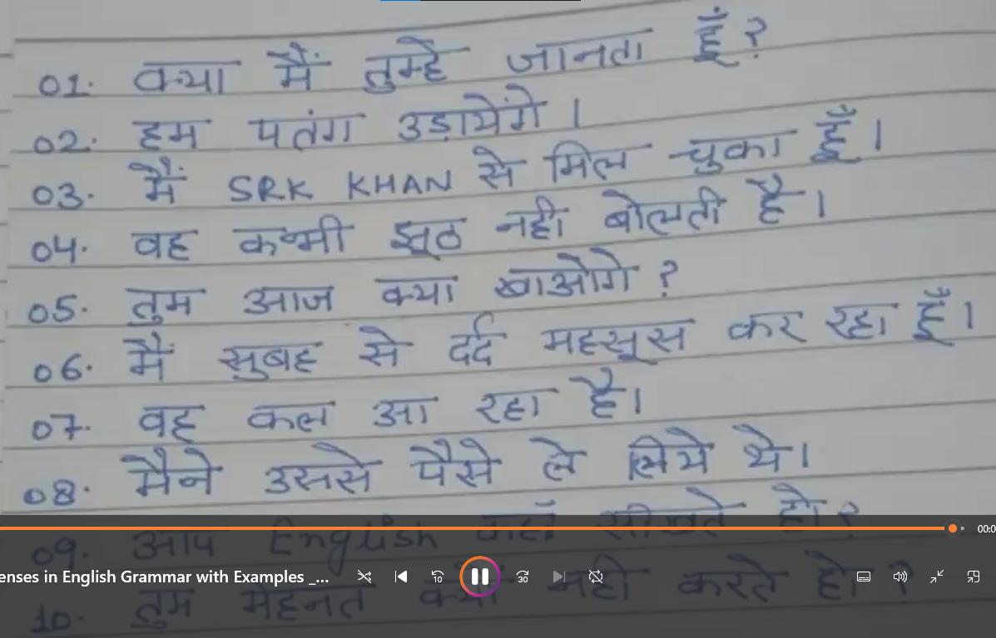

**Answers:-**

1. Do I know you?
2. We will fly the kite.
3. I have met the SRK khan
4. She never tells a lie.
5. What will you eat today?
6. I have been feeling pain since morning.
7. He is coming tomorrow.
8. I had taken the money from him.
9. From where you learn English?
10. Why do not you work hard?